
ANNA UNIVERSITY REGIONAL CAMPUS, COIMBATORE - 641 041

DEPARTMENT OF ELECTRONICS AND COMMUNICATION ENGINEERING
ACADEMIC YEAR 2023-2024 (SEMESTER 5)
IBM NAAN MUDHALVAN CLOUD COMPUTING PROJECT 3: PERSONAL BLOG ON IBM CLOUD STATIC WEB APP
PHASE 3: DEVELOPMENT PART 1
(Preprocessing the dataset)

DONE BY,
SRI HARIHARAN B
710021106306

PROJECT NAME:
PERSONAL BLOG OF STATIC WEB PAGE
PROJECT SUBMISSION: DEVELOPMENT PART 1

HTML CODE:
<!DOCTYPE html>
<html>
<head>
<title>Travel Website</title>
<link rel="preconnect" href="https://fonts.gstatic.com">
<link href="https://fonts.googleapis.com/css2?family=Poppins:wght@300&display=swap" rel="stylesheet">
<link rel="stylesheet" type="text/css" href="./style.css">
</head>
<body>
<div class="navbar">
<div class="logo">
<h1>Travel</h1>
</div>
<div class="menu">
<ul>
<li><a href="#">HOME</a></li>
<li><a href="./travel/html.html">TRAVEL STORIES</a></li>
<li><a href="./photogallery.html">TRAVEL TIPS</a></li>
<li><a href="./sidebar/index.html">PHOTO GALLERY</a></li>
<li><a href="./map.html">MAP</a></li>
<li><a href="./contact.html">CONTACT</a></li>

<li><a href="#">ABOUT ME</a></li>
</ul>
</div>
<div class="signup">
<a href="#">Sign Up</a>
</div>
</div>
<div class="body">
<div class="heading">
<h1>Travel With Us</h1>
<br>
<p>ipsum dolor sit amet, consectetur adipisicing elit, sed do eiusmod
tempor incididunt ut labore et dolore magna aliqua. </p>
<br>
<br>
<a href="#">Learn More</a>
</div>
<div class="tours">
<div class="places">
<h2>Australia</h2>
<img src="img1.jpg" style="width: 300px; height: 250px; border-radius: 12px;">
<br>
<br>
<a href="#">Book Now 15% OFF</a>
</div>
<div class="places">
<h2>New York</h2>
<img src="img2.jpg" style="width: 300px; height: 250px; border-radius: 12px;">
<br>
<br>
<a href="#">Book Now 20% OFF</a>
</div>
<div class="places">
<h2>Thailand</h2>
<img src="img3.jpg" style="width: 300px; height: 250px; border-radius: 12px;">
<br>
<br>
<a href="#">Book Now 25% OFF</a>
</div>
</div>
</div>
<div class="footer">
<a href="#">Copyright</a>
<a href="#">Terms and Conditions</a>
<a href="#">Privacy Policy</a>
<a href="#">Cookies</a>
<a href="#">Complaints</a>
</div>
</body>
</html>

STYLE.CSS:

*{
padding: 0px;
margin: 0px;
box-sizing: border-box;
list-style: none;
font-family: 'Poppins', sans-serif;

}
.navbar{
width: 100%;
height: 80px;
background-color: #fee;
display: flex;
justify-content: space-around;
align-items: center;
color: #000;
}
.menu ul{
display: flex;
align-items: center;
}
.menu ul li a{
text-decoration: none;
color: #000;
padding: 5px 12px;
letter-spacing: 2px;
font-size: 18px;
}
.menu ul li a:hover{
border-bottom: 4px solid #000;
transition: 0.4s;
}
.signup a{
text-decoration: none;
color: #000;
font-size: 18px;
font-weight: bold;
border-radius: 12px;
padding: 12px 30px;
border: 2px solid #ff0000;
}
.signup a:hover{
background-color: red;
transition: 0.6s;
}
.body{
width: 100%;
height: 90vh;
display: flex;
justify-content: space-around;
align-items: center;
background-image: linear-gradient(rgba(0,0,0,0.50),rgba(0,0,0,0.50)),url(img1.jpg);
background-position: center;
background-size: cover;
}
.heading{
width: 30%;
text-align: center;
color: #fff;
}
.heading h1{
font-size: 40px;
}
.heading a{
text-decoration: none;
color: #000;
font-size: 25px;
font-weight: bold;
border-radius: 45px;
padding: 14px 50px;
background-color: #fff;
}
.heading a:hover{
letter-spacing: 3px;
transition: 0.6s;
}
.tours{
width: 70%;
display: flex;
justify-content: space-around;
}
.places{
display: inline;
text-align: center;
border-radius: 12px;
}
.places h2{
color: red;
font-size: 35px;
letter-spacing: 3px;
border-radius: 1px;
padding: 30px 30px;
background-color: #000;
}
.places a{
text-decoration: none;
color: red;
font-weight: bold;
font-size: 18px;
border-radius: 12px;
padding: 12px 30px;
background-color: #fff;
}
.places a:hover{
background-color: #000;
letter-spacing: 3px;
transition: 0.6s;
}
.footer{
width: 100%;
height: 50px;
display: flex;
justify-content: space-around;
align-items: center;
}
.footer a{
text-decoration: none;
color: green;
font-size: 18px;
font-weight: bold;
}
.footer a:hover{
text-decoration: underline;
transition: 0.4s;
}

PHOTOGALLERY.CSS:

@import url("https://fonts.googleapis.com/css2?family=EB+Garamond:ital,wght@0,400;0,500;0,600;1,400;1,500;1,600&display=swap");

body {
max-width: 800px;
margin: 0 auto;
background: #e7dfcf;
}

section {
margin: 80px 0;
display: grid;
grid-template-areas: "title title img3 img3"
"img2 img1 img3 img3";
grid-gap: 8px;
}

h2 {
grid-area: title;
color: #111;
font-size: 120px;
font-family: "EB Garamond", serif;
font-weight: normal;
margin: 0 0 20px 0;
position: relative;
z-index: 1;
line-height: 1;
mix-blend-mode: hard-light;
max-width: 240px;

}
h2 span {
font-weight: bold;
}

h2::after {
display: none;
content: "";
height: 8px;
border-radius: 30px;
width: 70%;
/* display: block; */
background: currentColor;
transition: 0.5s ease;
}

h2:hover::after {
transform: translateX(50%);
}

section img:nth-child(4) {
grid-area: img3;
aspect-ratio: 3 / 4;
}
section img:nth-child(1) {
grid-area: img1;
}
section img:nth-child(2) {
grid-area: img2;
}
section img {
aspect-ratio: 4 / 3;
}

img {
max-width: 100%;
width: 100%;
height: 100%;
border-radius: 5px;
object-fit: cover;
transition: 0.3s ease;
box-shadow: 0 1px 3px 0 rgb(0 0 0 / 0.1), 0 1px 2px -1px rgb(0 0 0 / 0.1);

}

IMAGES:

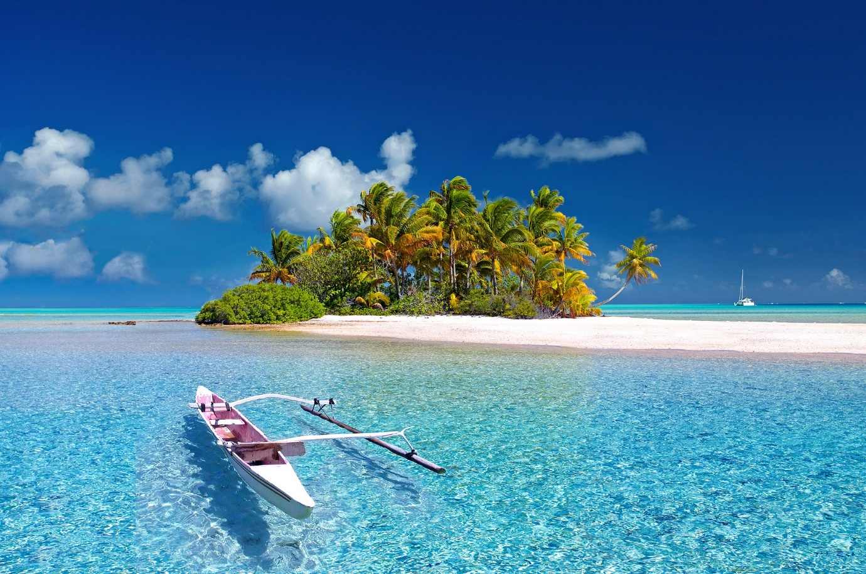

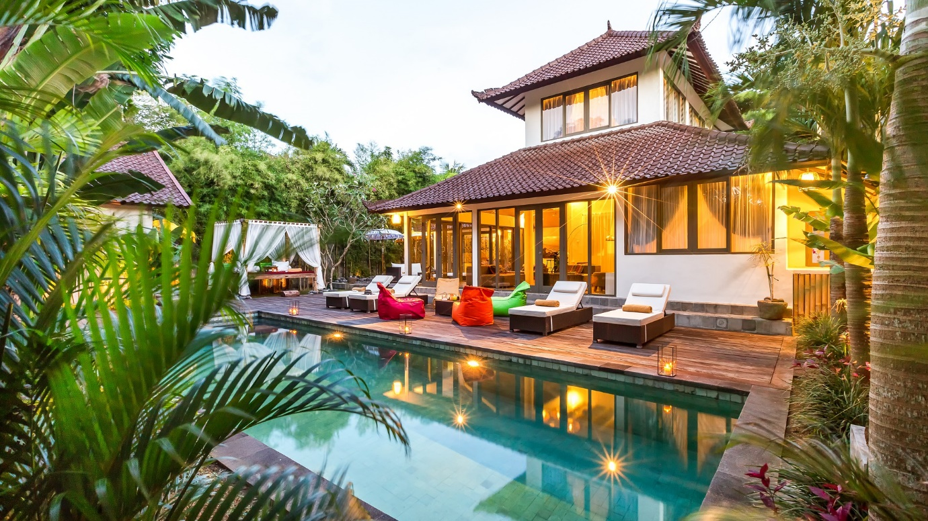

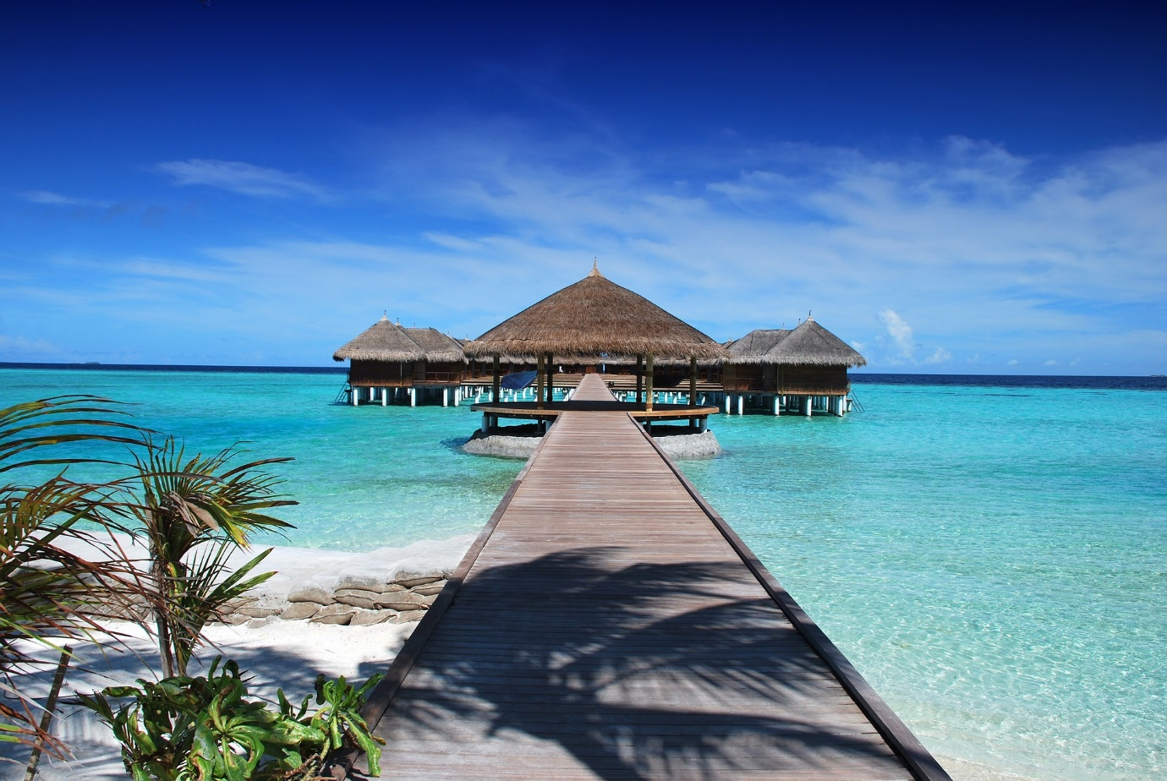
MAP:

